

 Wallet on Testnet – Set Up and Transact

**Objective/Aim:**  
  
 To configure MetaMask for a blockchain test network, obtain test cryptocurrency from a faucet, and perform a transaction on the testnet.

**Apparatus/Software Used:**

* Laptop
* Brave Browser
* MetaMask
* Google Web3 Faucet

**Theory/Concept:**

Testnets are like practice grounds for blockchain. They look and work like the real network but use fake coins so you can learn without losing money. MetaMask lets us connect to these networks and test how sending and receiving crypto works.



**Procedure:**

1. Switched to a Test Network

-Went to MetaMask settings, changed network to TestNet.

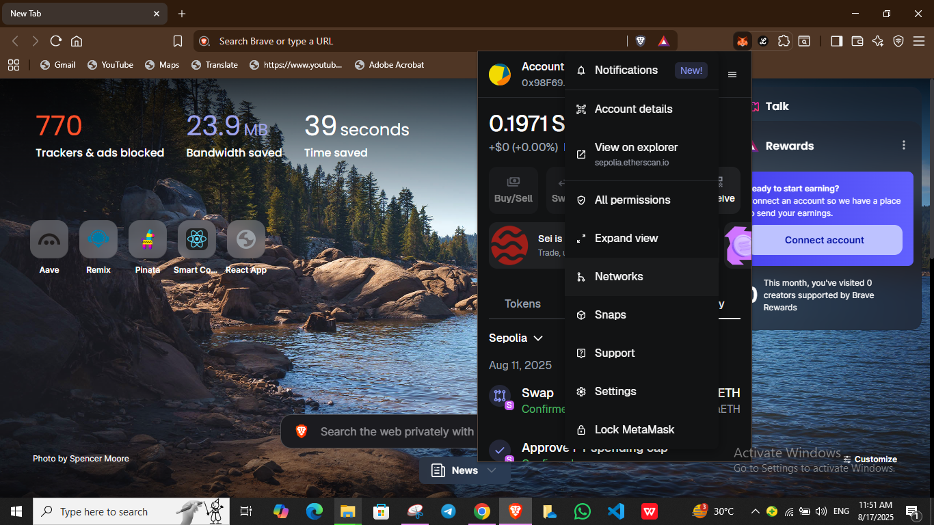 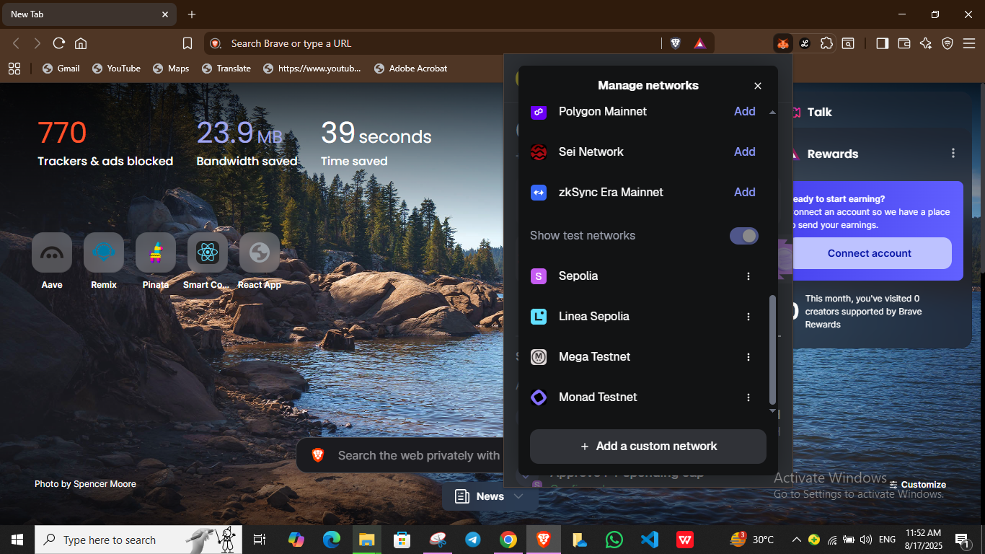

1. Got Some Free Test ETH

-Copied my wallet address from MetaMask

-Opened Google Web3 Faucet, pasted my address there and clicked “Receive”

-Waited a few seconds, the test ETH showed in my wallet.

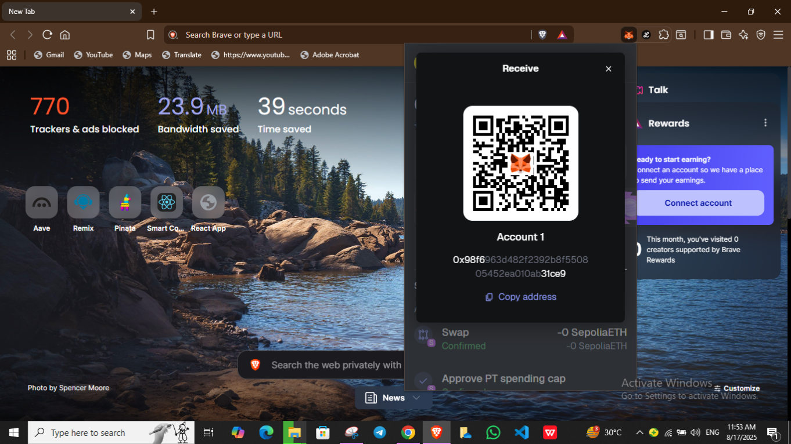 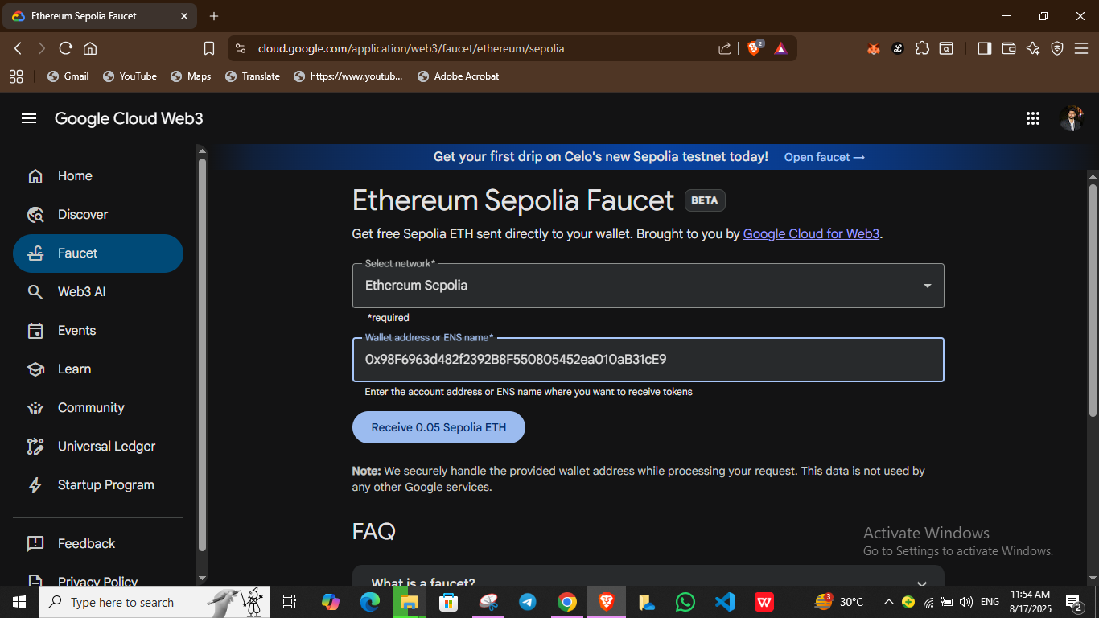

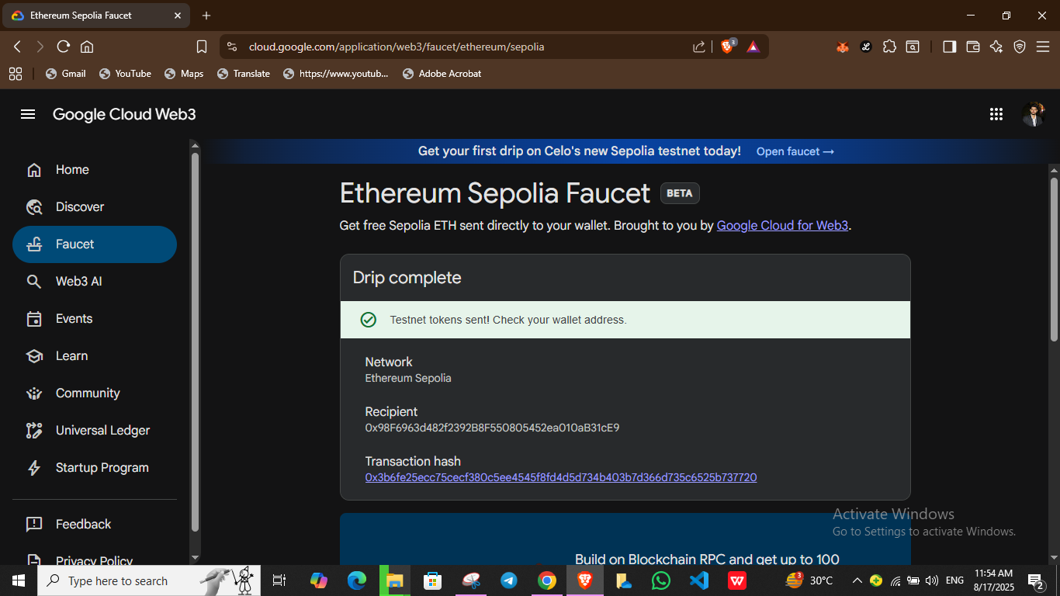

1. Sent a Transaction

-Clicked “Send” in MetaMask, pasted my friend’s wallet address.

-Sent 0.002 Sepolia, confirmed, and waited for the transaction to be approved.

-Checked the “Activity” section, my transaction was there.

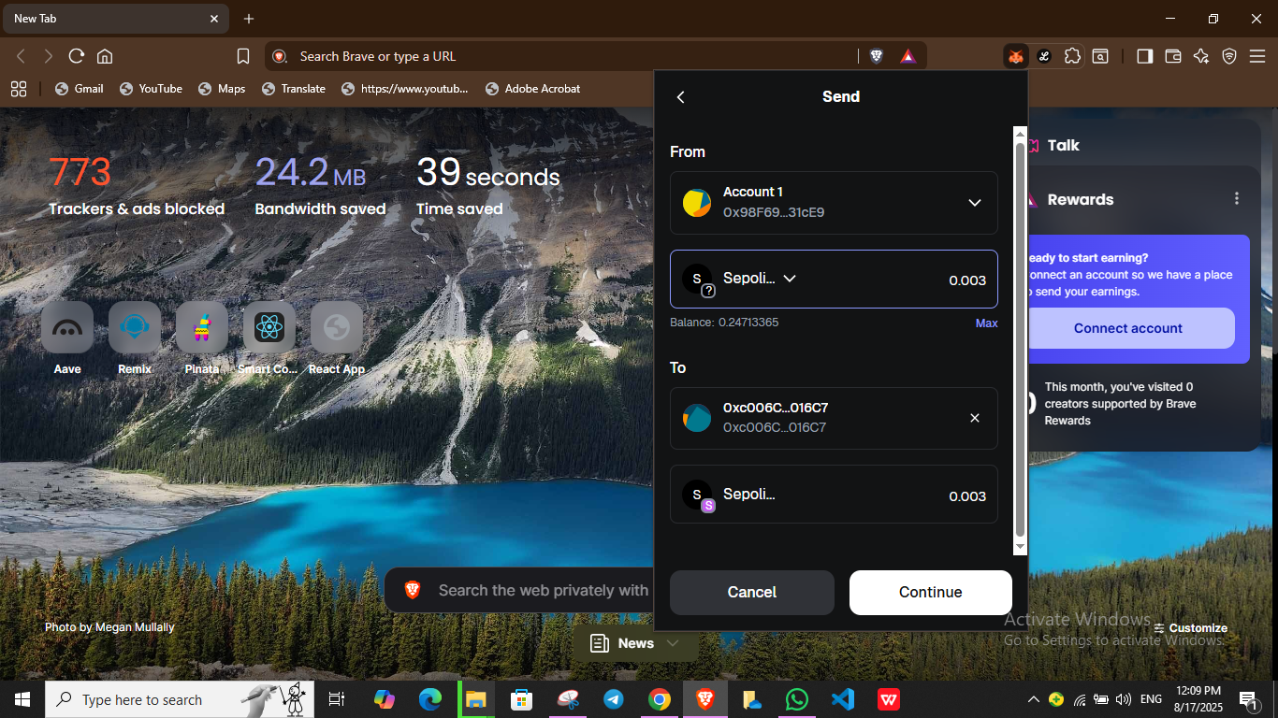 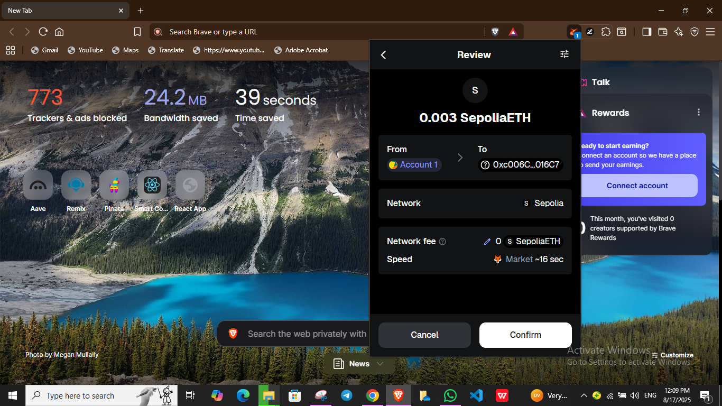 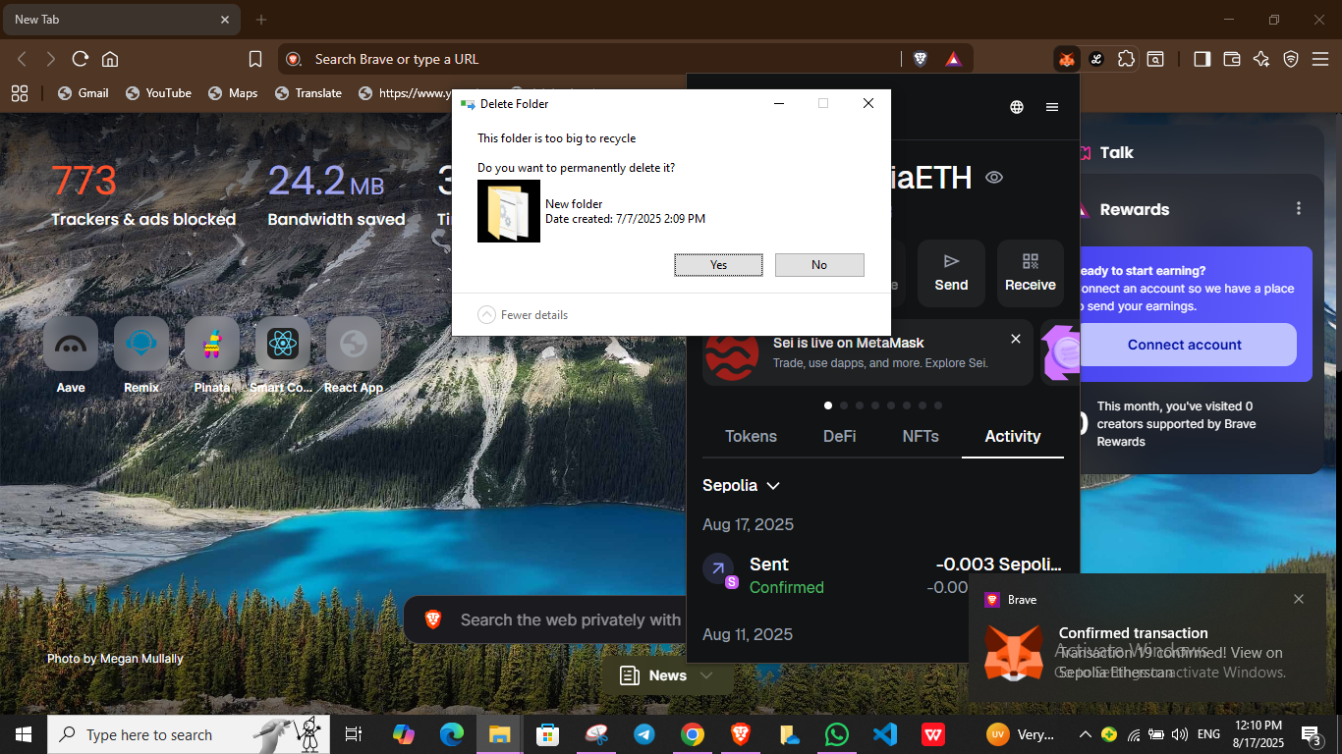

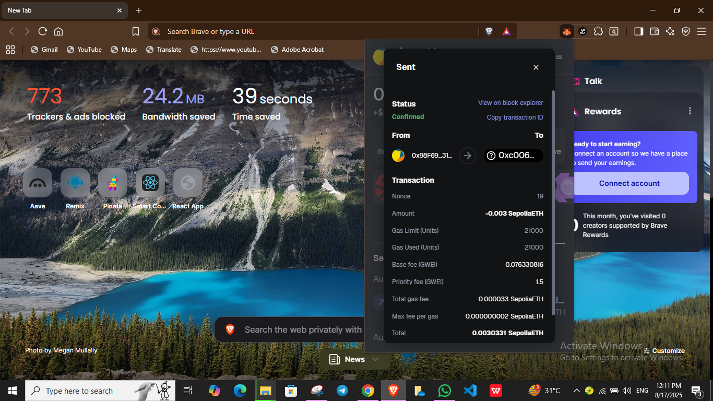

**Observation:**

1. The Sepolia network looks just like the main Ethereum network in MetaMask.
2. Test ETH arrived in about 30 seconds.
3. Sending coins on testnet also uses gas fees, but they’re paid with test ETH.

|  |  |  |  |
| --- | --- | --- | --- |
|  |  |  |  |
|  |  |  |  |
|  |  |  |  |
|  |  |  |  |
|  |  |  |  |
|  |  |  |  |
|  |  |  |  |

 

